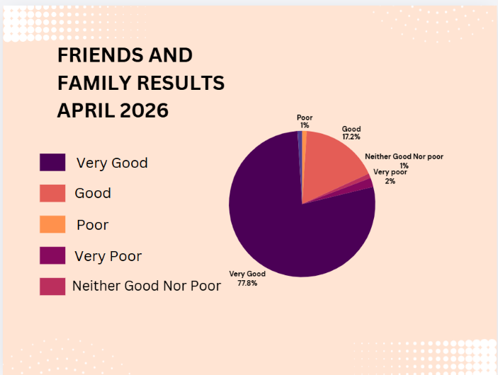
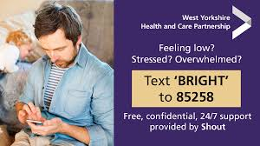
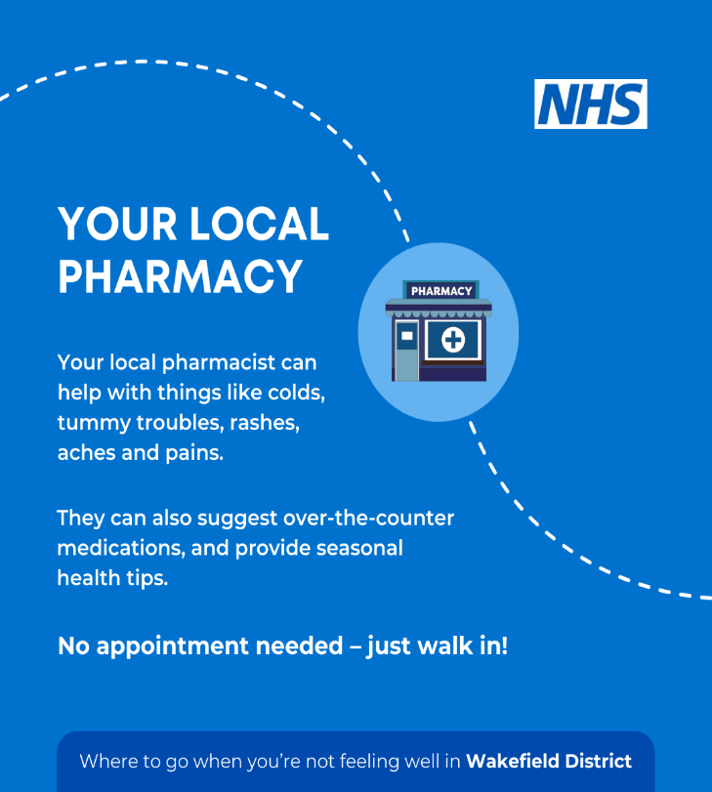

You can do so much more with the NHS App than you realise!
Quickly and easily request your repeat prescriptions
🧪 See test results 🧪
🔔 Turn on notifications and never miss a message 🔔

📄 View your GP health record anytime 📄

👉 Discover the NHS App: www.nhs.uk/nhsapp
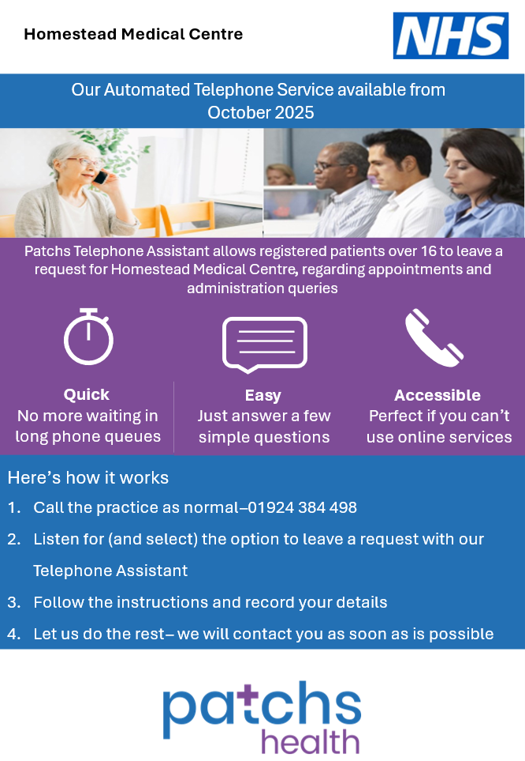

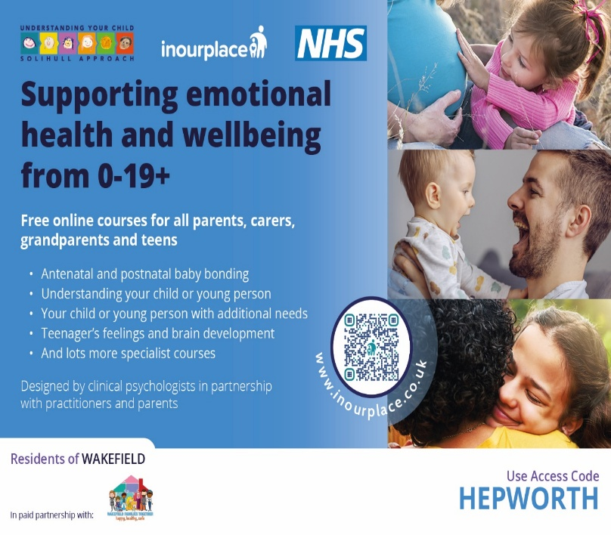
To help us provide the best possible care and ensure appointments are allocated appropriately, we are requesting your support when booking GP appointments
What’s changing?
When requesting a GP appointment, patients will now be asked to provide a brief reason for their request. This information helps our trained Care Navigators direct you to the most appropriate clinician or service as quickly as possible.
❗ Please note:
We will no longer accept “personal” as a reason for booking an appointment.
Why is this necessary?
This change has been introduced to ensure fair access for all patients. We have seen increasing misuse of GP appointments for requests that may be better handled by other members of our team or through alternative services (e.g. medication requests, sick notes, administrative queries).
🔒 Your privacy matters
All information provided will be treated confidentially and used only to support your care.
Thank you for your understanding and cooperation in helping us improve access to our services.
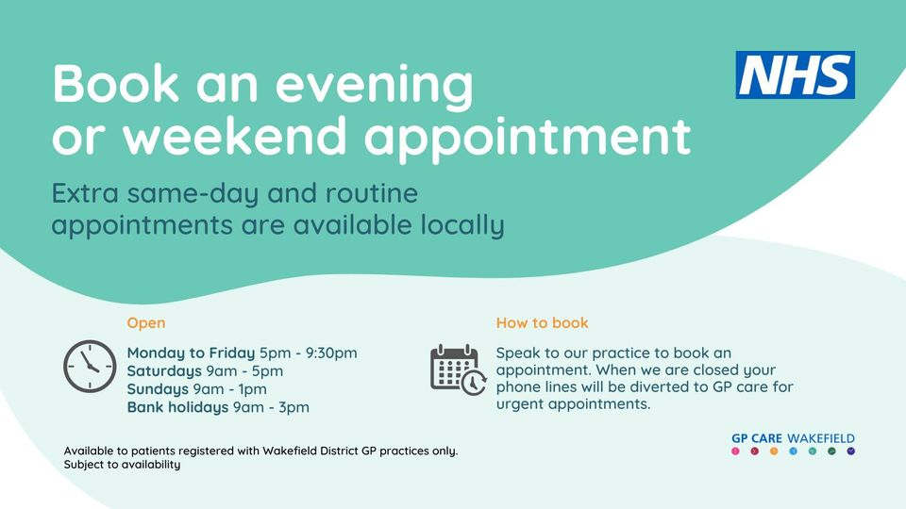
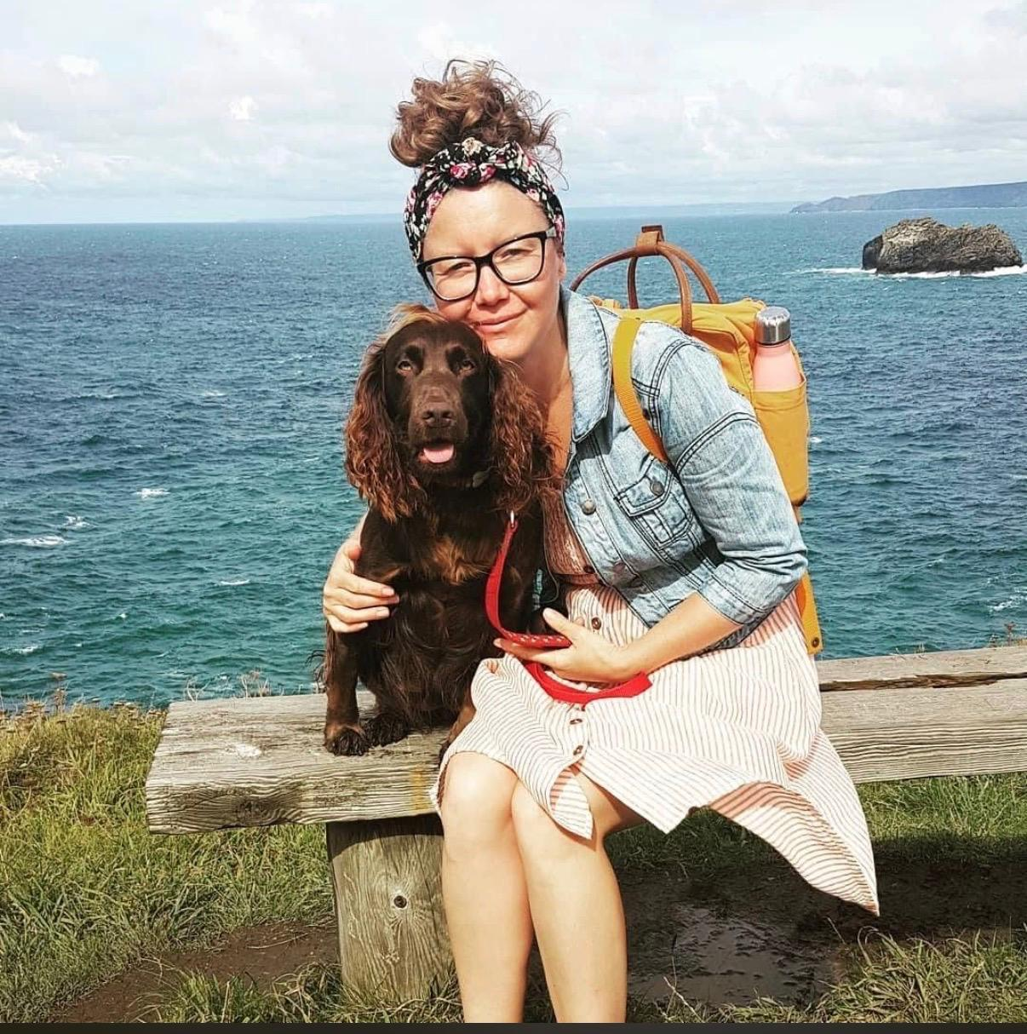
Many of you will be aware that we sadly lost Natalie, our much loved friend and Practice Nurse of 20 years in March at the age of 47 following a short illness.
Some of you may remember Natalie’s journey with the practice started 20 years ago when she joined us as a receptionist. Through dedication and determination Natalie went on to train as a phlebotomist, then as a Health Care Assistant and in in 2023 qualified as a Practice Nurse.
Lots of our patients have left touching messages of condolence and have enquired about donations in Natalie’s memory. Natalie had requested that any donations be made to the Prince of Wales Hospice

